

John Blow Primary School

Diversification & Anti-Racist Curriculum Overview
2025–2026
Our Journey So Far
During the 2024–2025 academic year, we began an important anti-racist initiative in collaboration with Dr Syra Shakir, Associate Professor and Strategic Lead on Race Equity at Leeds Trinity University . She supported us in delivering training and strategies that helped us examine bias and equality in our school.
As a result, we embarked on a broader Diversification Project, exploring the UK's nine Protected Characteristics defined in the Equality Act 2010:
- Age
- Disability
- Gender reassignment
- Marriage & civil partnership
- Pregnancy & maternity
- Race
- Religion or belief
- Sex
- Sexual orientation
Our goal has been to ensure our curriculum reflects and celebrates the diversity of our community and the wider world.

What's Coming This Year
Over the coming year, your child will engage in a wide range of enriching activities designed to develop their cultural capital and global awareness, including:
- Exploring Protected Characteristics through age-appropriate stories, art, and role-plays
- Anti-racist and empathy workshops fostering inclusion and mutual respect
- Cultural showcases, celebrating traditions, foods, music, and festivals from around the world
- Curriculum enhancements: literature, historical figures, scientific contributors, and artists representing diverse backgrounds
- Key events linked to our themes of diversity:
  - Black History Month (Oct)
  - International Women’s Day (Mar)
  - Science Week (Mar)
  - Sports Week (Summer Term)
  - Cultural Days tied to religious and traditional festivals
  - Yearly reflections each half term on our learning and actions
Why This Matters
- BROADENING PERSPECTIVES — Children see themselves reflected and learn about others, building understanding and empathy
- BUILDING CONFIDENCE — Celebrating differences helps children feel proud of who they are
- CHALLENGING INEQUALITY — We nurture critical thinking and call out unfairness when we see it
- PREPARING FOR A DIVERSE WORLD — These skills equip our children to thrive in an increasingly global society

How You Can Support
- Talk with your child about what they learn—ask about classes, stories, or projects
- Celebrate diversity at home—share your own family’s traditions or values
- Share ideas for experiences, cultural activities, or local connections we could include

In Summary
Our work with Dr Syra Shakir and the development of our Diversification Project reflects our school's dedication to equality, inclusion, and social justice. We are excited for another year of rewarding learning through rich, diverse experiences.

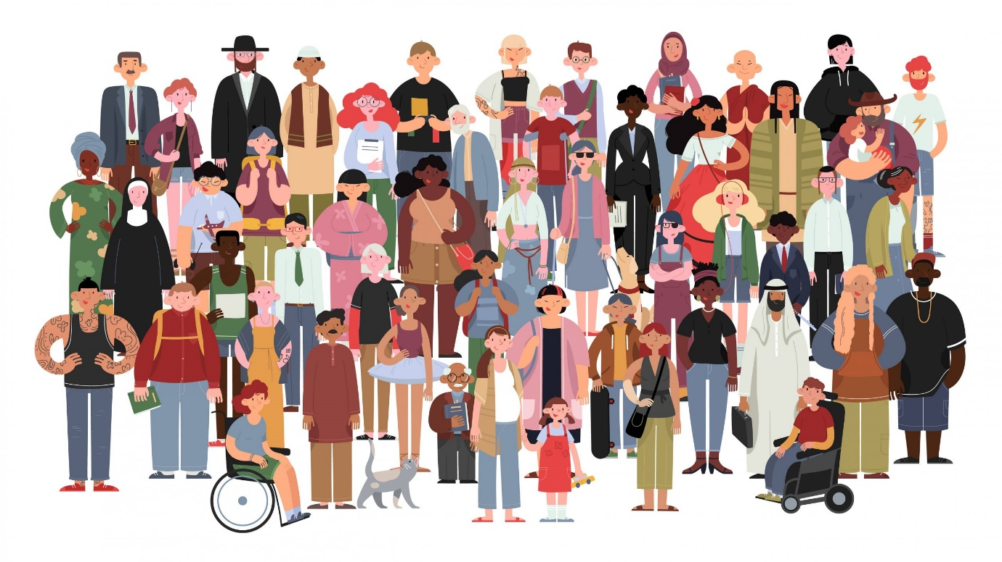
“Education is not preparation for life; education is life itself.”
John Dewey (1916)

