NEED HELP?

Collingham Area Pantry
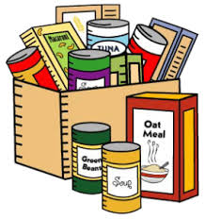
is offering a
FREE FOOD SHOP
& DELIVERY SERVICE

If you’re income has been hit by the virus or you’re not eligible for Government support PLEASE get in touch:

Email: collinghamfoodbank@gmail.com
Text or call: 07738 237 057
(All communications handled in confidence)
Further updates on facebook: Collingham Village Notts

With thanks to all our generous donors and helpers including Lincolnshire Co-op, Waitrose, Morrisons, Nottinghamshire CC & local individuals.

